Contents

Supplemental Table 1. Underlying data from studies included in Figure 2.
Supplemental Table 2. Baseline and final fasting plasma glucose (FPG) levels in the trial populations stratified by age, duration of diabetes, baseline FPG, and serum magnesium levels.
Supplemental Figure 1. Baseline and final conditions of serum magnesium levels (A) and fasting plasma glucose (B) in 315 individuals with type 2 diabetes.
Supplemental Figure 2. Serum magnesium (A) and plasma magnesium (B) changes in response to magnesium supplementation of different doses of elemental magnesium.
Supplemental Figure 3. Serum magnesium (A) and plasma magnesium (B) changes in response to magnesium supplementation with different durations.
Studies gathered on magnesium and blood pressure.

Supplemental Table 1. Underlying data from studies included in Figure 2.
Author (ref) | Outcome | Circulating Mg, mmol/L | Risk Estimate (95% CI)¹
Khan et al. (152) | Atrial fibrillation | 0.73 | 1.45 (0.99, 2.12)
 |  | 0.82 | 1
Misialek et al. (151) | Atrial fibrillation | 0.83 | 1
 |  | 0.73 | 1.24 (1.08, 1.43)
Misialek et al. (151) | Atrial fibrillation | 0.83 | 1
 |  | 0.90 | 1.10 (0.94, 1.28)
Chiuve et al. (147) | CHD morbidity/mortality | 0.82 | 1
 |  | 0.99 | 0.63 (0.38, 1.05)
Ford (158) | CHD mortality | 0.80 | 1
 |  | 0.89 | 0.69 (0.52, 0.90)
Ford (158) | CHD morbidity/mortality | 0.80 | 1
 |  | 0.89 | 0.92 (0.79, 1.07)
Gartside and Glueck (159) | CVD morbidity/mortality | 0.81 | 1
 |  | 0.87 | 0.68 (0.54, 0.87)
Joosten et al. (11) | CHD morbidity/mortality | 0.81 | 1
 |  | 0.77 | 1.06 (0.79, 1.43)
Joosten et al. (11) | CHD morbidity/mortality | 0.81 | 1
 |  | 0.85 | 1.07 (0.80, 1.43)
Kieboom et al. (149) | CHD morbidity/mortality | 0.84 | 1
 |  | 0.80 | 1.36 (1.09, 1.69)
Kieboom et al. (149) | CHD morbidity/mortality | 0.84 | 1
 |  | 0.89 | 0.94 (0.73, 1.21)
Liao et al. (154) | CHD morbidity/mortality | 0.75 | 1
 |  | 0.90 | 0.55 (0.27, 1.14)
Liao et al. (154) | CHD morbidity/mortality | 0.75 | 1
 |  | 0.90 | 0.84 (0.53, 1.31)
Peacock et al. (155) | CHD morbidity/mortality | 0.75 | 1
 |  | 0.88 | 0.69 (0.56, 0.84)
Khan et al. (160) | CVD morbidity/mortality | 0.76 | 1
 |  | 0.62 | 1.19 (0.60, 2.36)
Khan et al. (160) | CVD morbidity/mortality | 0.76 | 1
 |  | 0.90 | 1.10 (0.64, 1.89)
Leone et al. (161) | CVD morbidity/mortality | 0.76 | 1
 |  | 0.84 | 0.60 (0.20, 1.20)
Marniemi et al. (162)² | CVD morbidity/mortality | 0.75 | 1
 |  | 0.91 | 0.90 (0.58, 1.38)
Reffelmann et al. (150)³ | CVD morbidity/mortality | 0.81 | 1
 |  | 0.73 | 1.66 (1.13, 2.45)
Lutsey et al. (153) | Heart failure | 0.90 | 1
 |  | 0.70 | 1.66 (1.42, 1.95)
Akarolo-Anthony et al. (148) | Ischemic stroke | 0.95 | 1
 |  | 0.82 | 1.34 (0.82, 2.17)
Ohira et al. (156) | Ischemic stroke | 0.72 | 1
 |  | 0.92 | 0.83 (0.65, 1.05)
Chiuve et al. (157) | Sudden cardiac death | 0.78 | 1
 |  | 0.86 | 0.23 (0.09, 0.60)
Kieboom et al. (149) | Sudden cardiac death | 0.84 | 1
 |  | 0.80 | 1.54 (1.12, 2.11)
Kieboom et al. (149) | Sudden cardiac death | 0.84 | 1
 |  | 0.89 | 1.35 (0.96, 1.89)
Peacock et al. (155) | Sudden cardiac death | 0.75 | 1
 |  | 0.88 | 0.62 (0.42, 0.93)
¹Estimated risk ratios (from published odds ratios, relative risks, or hazard ratios are from comparisons of the cut-point of circulating Mg in cases versus controls, or in a risk quantile versus the reference quantile. A study may appear twice if (1) it examined multiple outcomes; (2) it included stratified analyses (e.g., by sex); or (3) the reference value was a middle quartile value, in which case the risk estimates appear for both lower and higher Mg values in addition to the reference Mg value. Risk and reference Mg levels were converted to mmol/L when not presented as such in the original report. In Figure 2 of the manuscript, the risk estimate at a given circulating Mg level is connected to its corresponding reference Mg level by a line, for the following outcomes: atrial fibrillation (closed circles); coronary heart disease morbidity/mortality (closed squares); cardiovascular disease morbidity/mortality (open circles); heart failure (open squares); ischemic stroke (open diamonds); sudden cardiac death (shaded circles).
²Analyses were presented in tertiles without explicit serum Mg values, thus the lowest (reference) and highest tertile category Mg values were estimated from the given mean Mg value in vascular deaths ± 1 SD (0.83 ± 0.08 mmol/L).
³Analyses were presented as <0.73 versus ≥0.73 mmol/L, thus the reference value was selected as 0.73 mmol/L, and the upper value was selected as 0.73 + 0.08 mmol/L, in which 0.08 mmol/L is based on the distribution in another study.
Abbreviations: CHD, coronary heart disease; CI, confidence interval; CVD, cardiovascular disease; Mg, magnesium.

Supplemental Table 2. Baseline and final fasting plasma glucose (FPG) levels in the trial populations stratified by age, duration of diabetes, baseline FPG, and serum magnesium levels.
 |  | Age, y |  | Diabetes duration, y |  | Baseline FPG,  mmol/L |  |  | Serum Mg,  mmol/L
 | <60  n = 113 |  | ≥60  n = 202 | <10  n = 143 | ≥10  n = 172 |  | <10.2  n = 105 | ≥10.2  n = 210 |  | <0.74  n = 137 | ≥0.74  n = 178
FPG, Baseline | 11.3±3.5 |  | 9.6±1.54* | 11.0±2.8 | 11.1±2.7 |  | 8.8±0.4 | 12.0±4.0* |  | 11.2±3.4 | 9.7±1.3*
FPG, Final, | 9.5±2.6⁺ |  | 9.4±1.9 | 9.7±2.3⁺ | 9.3±2.1⁺ |  | 8.2±0.3⁺ | 10.5±3.3^{+, #} |  | 10.1±3.2⁺ | 8.6±1.2^{+, #}
Values are mean ± SD. Data were analyzed using unpaired Student’s t-test with differences considered significant at P<0.5:
* Groups differ at baseline;
⁺ Baseline differs from final;
# Groups differ at final.
Estimates derived from (125-126, 130-131-167-172).
Abbreviations: FPG, fasting plasma glucose; Mg, magnesium.

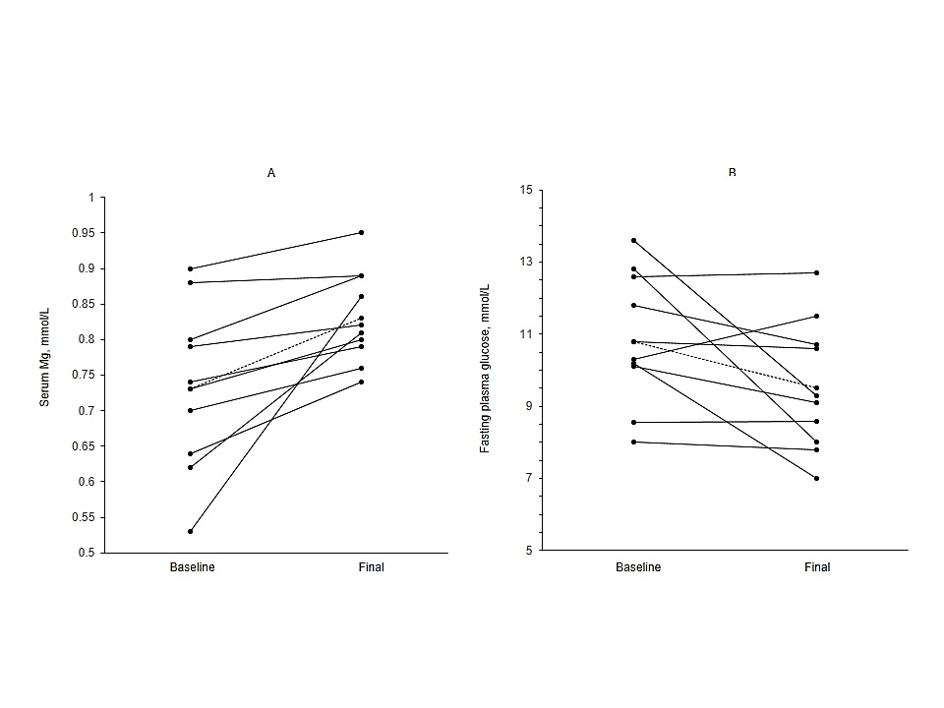
Supplemental Figure 1. Baseline and final conditions of serum magnesium levels (A) and fasting plasma glucose (B) in 315 individuals with type 2 diabetes who received a mean 20.5±8.2 mmol/d of elemental magnesium over a mean 11.5±5.9 weeks (125-126, 130-131-167-172). Black points and lines represent mean values from baseline to final measures in each trial. Dotted lines indicate the mean values from baseline to final measures across all trials. Abbreviation: Mg, magnesium.

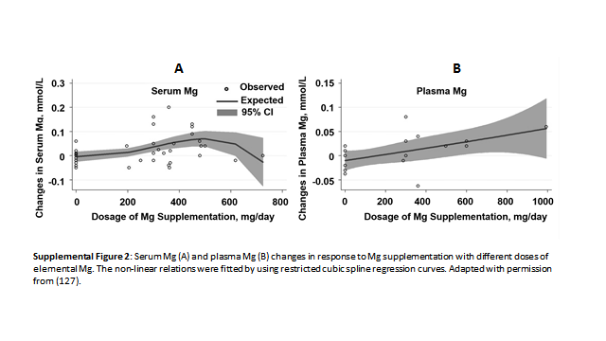
Supplemental Figure 2. Serum magnesium (A) and plasma magnesium (B) changes in response to magnesium supplementation of different doses of elemental magnesium. The non-linear relations were fitted by using restricted cubic spline regression curves. Adapted with permission from (173). Abbreviation: Mg, magnesium.

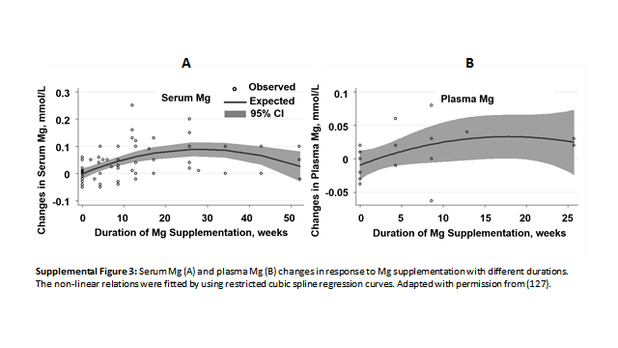
Supplemental Figure 3. Serum magnesium (A) and plasma magnesium (B) changes in response to magnesium supplementation with different durations. The non-linear relations were fitted by using restricted cubic spline regression curves. Adapted with permission from (173). Abbreviation: Mg, magnesium.

Studies gathered on magnesium and blood pressure.

- Abbasi IU, Salim ul H, Kausar MW, Karira KA, Zubaris NA. Correlation of divalent cat ions (Ca++, Mg++) and serum renin in pateints of essential hypertension. J Pak Med Assoc 2012;62(2):134-8.
- Afsar B, Elsurer R. The relationship between magnesium and ambulatory blood pressure, augmentation index, pulse wave velocity, total peripheral resistance, and cardiac output in essential hypertensive patients. J Am Soc Hypertens 2014;8(1):28-35.
- Baker WL, Kluger J, White CM, Dale KM, Silver BB, Coleman CI. Effect of magnesium L-lactate on blood pressure in patients with an implantable cardioverter defibrillator. Ann Pharmacother 2009;43(4):569-76.
- Barbagallo M, Dominguez LJ, Galioto A, Pineo A, Belvedere M. Oral magnesium supplementation improves vascular function in elderly diabetic patients. Magnes Res 2010;23(3):131-7.
- Barragan-Rodriguez L, Rodriguez-Moran M, Guerrero-Romero F. Efficacy and safety of oral magnesium supplementation in the treatment of depression in the elderly with type 2 diabetes: a randomized, equivalent trial. Magnes Res 2008;21(4):218-23.
- Bashir Y, Sneddon JF, Staunton HA, Haywood GA, Simpson IA, McKenna WJ, Camm AJ. Effects of long-term oral magnesium chloride replacement in congestive heart failure secondary to coronary artery disease. Am J Cardiol 1993;72(15):1156-62.
- Borghi L, Meschi T, Guerra A, Briganti A, Schianchi T, Allegri F, Novarini A. Essential arterial hypertension and stone disease. Kidney Int 1999;55(6):2397-406.
- Borrello G, Mastroroberto P, Curcio F, Chello M, Zofrea S, Mazza M. The effects of magnesium oxide on mild essential hypertension and quality of life. Current therapeutic research. Curr Ther Res 1996;57(10):767-74.
- Cappuccio FP, Markandu ND, Beynon GW, Shore AC, Sampson B, MacGregor GA. Lack of effect of oral magnesium on high blood pressure: a double blind study. Br Med J (Clin Res Ed) 1985;291(6490):235-8.
- Cohen L, Laor A, Kitzes R. Reversible retinal vasospasm in magnesium-treated hypertension despite no significant change in blood pressure. Magnesium 1984;3(3):159-63.
- Corica F, Allegra A, Ientile R, Buemi M. Magnesium concentrations in plasma, erythrocytes, and platelets in hypertensive and normotensive obese patients. Am J Hypertens 1997;10(11):1311-3.
- Corica F, Allegra A, Ientile R, Buemi M, Corsonello A, Bonanzinga S, Macaione S, Ceruso D. Changes in plasma, erythrocyte, and platelet magnesium levels in normotensive and hypertensive obese subjects during oral glucose tolerance test. Am J Hypertens 1999;12(2 Pt 1):128-36.
- Cosaro E, Bonafini S, Montagnana M, Danese E, Trettene MS, Minuz P, Delva P, Fava C. Effects of magnesium supplements on blood pressure, endothelial function and metabolic parameters in healthy young men with a family history of metabolic syndrome. Nutr Metab Cardiovasc Dis 2014;24(11):1213-20.
- Cunha AR, Medeiros F, Umbelino B, Oigman W, Touyz RM, Neves MF. Altered vascular structure and wave reflection in hypertensive women with low magnesium levels. J Am Soc Hypertens 2013;7(5):344-52.
- de Valk HW, Verkaaik R, van Rijn HJ, Geerdink RA, Struyvenberg A. Oral magnesium supplementation in insulin-requiring Type 2 diabetic patients. Diabet Med 1998;15(6):503-7.
- Doyle L, Flynn A, Cashman K. The effect of magnesium supplementation on biochemical markers of bone metabolism or blood pressure in healthy young adult females. Eur J Clin Nutr 1999;53(4):255-61.
- Dyckner T, Wester PO. Effect of magnesium on blood pressure. Br Med J (Clin Res Ed) 1983;286(6381):1847-9.
- Eriksson J, Kohvakka A. Magnesium and ascorbic acid supplementation in diabetes mellitus. Ann Nutr Metab 1995;39(4):217-23.
- Ferrara LA, Iannuzzi R, Castaldo A, Iannuzzi A, Dello Russo A, Mancini M. Long-term magnesium supplementation in essential hypertension. Cardiology 1992;81(1):25-33.
- Guerrero-Romero F, Rodriguez-Moran M. The effect of lowering blood pressure by magnesium supplementation in diabetic hypertensive adults with low serum magnesium levels: a randomized, double-blind, placebo-controlled clinical trial. J Hum Hypertens 2009;23(4):245-51.
- Guerrero-Romero F, Rodriguez-Moran M. Magnesium improves the beta-cell function to compensate variation of insulin sensitivity: double-blind, randomized clinical trial. Eur J Clin Invest 2011;41(4):405-10.
- Guerrero-Romero F, Rodriguez-Moran M. Serum magnesium in the metabolically-obese normal-weight and healthy-obese subjects. Eur J Intern Med 2013;24(7):639-43.
- Guerrero-Romero F, Tamez-Perez HE, Gonzalez-Gonzalez G, Salinas-Martinez AM, Montes-Villarreal J, Trevino-Ortiz JH, Rodriguez-Moran M. Oral magnesium supplementation improves insulin sensitivity in non-diabetic subjects with insulin resistance. A double-blind placebo-controlled randomized trial. Diabetes Metab 2004;30(3):253-8.
- Haga H. Effects of dietary magnesium supplementation on diurnal variations of blood pressure and plasma Na+, K(+)-ATPase activity in essential hypertension. Jpn Heart J 1992;33(6):785-800.
- Hatzistavri LS, Sarafidis PA, Georgianos PI, Tziolas IM, Aroditis CP, Zebekakis PE, Pikilidou MI, Lasaridis AN. Oral magnesium supplementation reduces ambulatory blood pressure in patients with mild hypertension. Am J Hypertens 2009;22(10):1070-5.
- Henderson DG, Schierup J, Schodt T. Effect of magnesium supplementation on blood pressure and electrolyte concentrations in hypertensive patients receiving long term diuretic treatment. Br Med J (Clin Res Ed) 1986;293(6548):664-5.
- Itoh K, Kawasaka T, Nakamura M. The effects of high oral magnesium supplementation on blood pressure, serum lipids and related variables in apparently healthy Japanese subjects. Br J Nutr 1997;78(5):737-50.
- Joosten MM, Gansevoort RT, Mukamal KJ, van der Harst P, Geleijnse JM, Feskens EJ, Navis G, Bakker SJ. Urinary and plasma magnesium and risk of ischemic heart disease. Am J Clin Nutr 2013;97(6):1299-306.
- Kawano Y, Matsuoka H, Takishita S, Omae T. Effects of magnesium supplementation in hypertensive patients: assessment by office, home, and ambulatory blood pressures. Hypertension 1998;32(2):260-5.
- Kesteloot H, Tzoulaki I, Brown IJ, Chan Q, Wijeyesekera A, Ueshima H, Zhao L, Dyer AR, Unwin RJ, Stamler J, et al. Relation of urinary calcium and magnesium excretion to blood pressure: The International Study Of Macro- And Micro-nutrients And Blood Pressure and The International Cooperative Study On Salt, Other Factors, And Blood Pressure. Am J Epidemiol 2011;174(1):44-51.
- Khan AM, Lubitz SA, Sullivan LM, Sun JX, Levy D, Vasan RS, Magnani JW, Ellinor PT, Benjamin EJ, Wang TJ. Low serum magnesium and the development of atrial fibrillation in the community: the Framingham Heart Study. Circulation 2013;127(1):33-8.
- Lee S, Park HK, Son SP, Lee CW, Kim IJ, Kim HJ. Effects of oral magnesium supplementation on insulin sensitivity and blood pressure in normo-magnesemic nondiabetic overweight Korean adults. Nutr Metab Cardiovasc Dis 2009;19(11):781-8.
- Li J, Wang J, Chen X, Tong S, Fang J, Yu H. Cross-sectional survey of intralymphocytic and serum elements in hypertensive patients. Chin Med J (Engl) 1999;112(7):641-5.
- Li YH, Nara Y, Huang ZD, Ishinaga Y, Rao XX, Yamori Y, Cen RC, Zhang K, Chen PF, Ma LM, et al. Trends of diet and blood pressure in Guangzhou, South China. J Cardiovasc Pharmacol 1990;16 Suppl 8:S6-8.
- Lind L, Lithell H, Pollare T, Ljunghall S. Blood pressure response during long-term treatment with magnesium is dependent on magnesium status. A double-blind, placebo-controlled study in essential hypertension and in subjects with high-normal blood pressure. Am J Hypertens 1991;4(8):674-9.
- Liu L, Mizushima S, Ikeda K, Hattori H, Miura A, Gao M, Nara Y, Yamori Y. Comparative studies of diet-related factors and blood pressure among Chinese and Japanese: results from the China-Japan Cooperative Research of the WHO-CARDIAC Study. Cardiovascular Disease and Alimentary Comparison. Hypertens Res 2000;23(5):413-20.
- Ma J, Folsom AR, Melnick SL, Eckfeldt JH, Sharrett AR, Nabulsi AA, Hutchinson RG, Metcalf PA. Associations of serum and dietary magnesium with cardiovascular disease, hypertension, diabetes, insulin, and carotid arterial wall thickness: the ARIC study. Atherosclerosis Risk in Communities Study. J Clin Epidemiol 1995;48(7):927-40.
- Michon P. [Level of total and ionized magnesium fraction based on biochemical analysis of blood and hair and effect of supplemented magnesium (Slow Mag B6) on selected parameters in hypertension of patients treated with various groups of drugs]. Ann Acad Med Stetin 2002;48:85-97.
- Mooren FC, Kruger K, Volker K, Golf SW, Wadepuhl M, Kraus A. Oral magnesium supplementation reduces insulin resistance in non-diabetic subjects - a double-blind, placebo-controlled, randomized trial. Diabetes Obes Metab 2011;13(3):281-4.
- Motoyama T, Sano H, Fukuzaki H. Oral magnesium supplementation in patients with essential hypertension. Hypertension 1989;13(3):227-32.
- Nowson CA, Morgan TO. Magnesium supplementation in mild hypertensive patients on a moderately low sodium diet. Clin Exp Pharmacol Physiol 1989;16(4):299-302.
- Olhaberry JV, Reyes AJ, Acosta-Barrios TN, Leary WP, Queiruga G. Pilot evaluation of the putative antihypertensive effect of magnesium. Mag-Bul 1987;9:181-4.
- Onyesom I, Inmuere F, Awhin PE. Levels of some micronutrients in some Nigerian hypertensives. East Afr J Public Health 2011;8(3):212-5.
- Ozono R, Oshima T, Matsuura H, Higashi Y, Ishida T, Watanabe M, Yoshimura M, Hiraga H, Ono N, Kajiyama G. Systemic magnesium deficiency disclosed by magnesium loading test in patients with essential hypertension. Hypertens Res 1995;18(1):39-42.
- Panhwar AH, Kazi TG, Afridi HI, Talpur FN, Arain S, Kazi N. Distribution of potassium, calcium, magnesium, and sodium levels in biological samples of Pakistani hypertensive patients and control subjects. Clin Lab 2014;60(3):463-74.
- Paolisso G, Sgambato S, Gambardella A, Pizza G, Tesauro P, Varricchio M, D'Onofrio F. Daily magnesium supplements improve glucose handling in elderly subjects. Am J Clin Nutr 1992;55(6):1161-7.
- Peacock JM, Folsom AR, Arnett DK, Eckfeldt JH, Szklo M. Relationship of serum and dietary magnesium to incident hypertension: the Atherosclerosis Risk in Communities (ARIC) Study. Ann Epidemiol 1999;9(3):159-65.
- Plum-Wirell M, Stegmayr BG, Wester PO. Nutritional magnesium supplementation does not change blood pressure nor serum or muscle potassium and magnesium in untreated hypertension. A double-blind crossover study. Magnes Res 1994;7(3-4):277-83.
- Purvis JR, Cummings DM, Landsman P, Carroll R, Barakat H, Bray J, Whitley C, Horner RD. Effect of oral magnesium supplementation on selected cardiovascular risk factors in non-insulin-dependent diabetics. Arch Fam Med 1994;3(6):503-8.
- Reffelmann T, Ittermann T, Dorr M, Volzke H, Reinthaler M, Petersmann A, Felix SB. Low serum magnesium concentrations predict cardiovascular and all-cause mortality. Atherosclerosis 2011;219(1):280-4.
- Resnick LM, Oparil S, Chait A, Haynes RB, Kris-Etherton P, Stern JS, Clark S, Holcomb S, Hatton DC, Metz JA, et al. Factors affecting blood pressure responses to diet: the Vanguard study. Am J Hypertens 2000;13(9):956-65.
- Reyes AJ, Leary WP, Acosta-Barrios TN, . , Davis WH. Magnesium supplementation in hypertension treated with hydrochlorothiazide. Curr Therap Res 1984;36:332-40.
- Rodriguez-Hernandez H, Cervantes-Huerta M, Rodriguez-Moran M, Guerrero-Romero F. Oral magnesium supplementation decreases alanine aminotransferase levels in obese women. Magnes Res 2010;23(2):90-6.
- Rodriguez-Moran M, Guerrero-Romero F. Oral magnesium supplementation improves the metabolic profile of metabolically obese, normal-weight individuals: a randomized double-blind placebo-controlled trial. Arch Med Res 2014;45(5):388-93.
- Rodriguez-Moran M, Guerrero-Romero F. Hypomagnesemia and prehypertension in otherwise healthy individuals. European journal of internal medicine 2014;25(2):128-31. doi: 10.1016/j.ejim.2013.08.706.
- Rubio-Luengo MA, Maldonado-Martin A, Gil-Extremera B, Gonzalez-Gomez L, Luna del Castillo JD. Variations in magnesium and zinc in hypertensive patients receiving different treatments. Am J Hypertens 1995;8(7):689-95.
- Rylander R, Arnaud MJ. Mineral water intake reduces blood pressure among subjects with low urinary magnesium and calcium levels. BMC Public Health 2004;4:56.
- Sacks FM, Brown LE, Appel L, Borhani NO, Evans D, Whelton P. Combinations of potassium, calcium, and magnesium supplements in hypertension. Hypertension 1995;26(6 Pt 1):950-6.
- Sacks FM, Willett WC, Smith A, Brown LE, Rosner B, Moore TJ. Effect on blood pressure of potassium, calcium, and magnesium in women with low habitual intake. Hypertension 1998;31(1):131-8.
- Saito K, Hattori K, Omatsu T, Hirouchi H, Sano H, Fukuzaki H. Effects of oral magnesium on blood pressure and red cell sodium transport in patients receiving long-term thiazide diuretics for hypertension. Am J Hypertens 1988;1(3 Pt 3):71s-4s.
- Sanjuliani AF, de Abreu Fagundes VG, Francischetti EA. Effects of magnesium on blood pressure and intracellular ion levels of Brazilian hypertensive patients. Int J Cardiol 1996;56(2):177-83.
- Sarkkinen ES, Kastarinen MJ, Niskanen TH, Karjalainen PH, Venalainen TM, Udani JK, Niskanen LK. Feasibility and antihypertensive effect of replacing regular salt with mineral salt -rich in magnesium and potassium- in subjects with mildly elevated blood pressure. Nutr J 2011;10:88.
- Sasaki S, Oshima T, Matsuura H, Ozono R, Higashi Y, Sasaki N, Matsumoto T, Nakano Y, Ueda A, Yoshimizu A, et al. Abnormal magnesium status in patients with cardiovascular diseases. Clin Sci (Lond) 2000;98(2):175-81.
- Sebekova K, Revusova V, Polakovicova D, Drahosova J, Zverkova D, Dzurik R. Anti-hypertensive treatment with magnesium-aspartate-dichloride and its influence on peripheral serotonin metabolism in man: a subacute study. Cor Vasa 1992;34(5-6):390-401.
- Shafique M, Misbah ul A, Ashraf M. Role of magnesium in the management of hypertension. J Pak Med Assoc 1993;43(4):77-8.
- Shahid SM, Jawed M, Mahboob T. Ionic and allied variations in normotensive and hypertensive diabetic patients. J Pak Med Assoc 2005;55(4):153-8.
- Shibutani Y, Sakamoto K, Katsuno S, Yoshimoto S, Matsuura T. Relation of serum and erythrocyte magnesium levels to blood pressure and a family history of hypertension. A follow-up study in Japanese children, 12-14 years old. Acta Paediatr Scand 1990;79(3):316-21.
- Simental-Mendia LE, Rodriguez-Moran M, Guerrero-Romero F. Oral magnesium supplementation decreases C-reactive protein levels in subjects with prediabetes and hypomagnesemia: a clinical randomized double-blind placebo-controlled trial. Arch Med Res 2014;45(4):325-30.
- Song Y, He K, Levitan EB, Manson JE, Liu S. Effects of oral magnesium supplementation on glycaemic control in Type 2 diabetes: a meta-analysis of randomized double-blind controlled trials. Diabet Med 2006;23(10):1050-6.
- Sur G, Maftel O. Role of magnesium in essential hypertension in teenagers. Edtion ed. In: Porr PJ, Nechifor M, Durlach J, eds. Advances in Magnesium Research: New Data. Montrouge: John Libbey Eurotext, 2006:55-9.
- Taylor DR, Constable J, Sonnekus M, Milne FJ. Effect of indapamide on serum and red cell cations, with and without magnesium supplementation, in subjects with mild hypertension. S Afr Med J 1988;74(6):273-6.
- Touyz RM, Milne FJ, Reinach SG. Altered calcium binding to erythrocyte membranes in essential hypertension: relation to magnesium. J Hum Hypertens 1993;7(1):59-64.van Berge-Landry H, James GD. Serum electrolyte, serum protein, serum fat and renal responses to a dietary sodium challenge: allostasis and allostatic load. Ann Hum Biol 2004;31(4):477-87.
- van Berge-Landry H, James GD. Serum electrolyte, serum protein, serum fat and renal responses to a dietary sodium challenge: allostasis and allostatic load. Ann Hum Biol 2004;31(4):477-87. doi: 10.1080/03014460412331281746.
- Wary C, Brillault-Salvat C, Bloch G, Leroy-Willig A, Roumenov D, Grognet JM, Leclerc JH, Carlier PG. Effect of chronic magnesium supplementation on magnesium distribution in healthy volunteers evaluated by 31P-NMRS and ion selective electrodes. Br J Clin Pharmacol 1999;48(5):655-62.
- Widman L, Wester PO, Stegmayr BK, Wirell M. The dose-dependent reduction in blood pressure through administration of magnesium. A double blind placebo controlled cross-over study. Am J Hypertens 1993;6(1):41-5.
- Wirell MM, Wester P, O., Stegmayr B. Nutritional dose of magnesium given to short-term thiazide treated hypertensive patients does not alter the blood pressure or the magnesium and potassium in muscle -a double blind cross over study. Mag-Bul 1993;15(2):50-4.
- Wirell MP, Wester PO, Stegmayr BG. Nutritional dose of magnesium in hypertensive patients on beta blockers lowers systolic blood pressure: a double-blind, cross-over study. J Intern Med 1994;236(2):189-95.
- Witteman JC, Grobbee DE, Derkx FH, Bouillon R, de Bruijn AM, Hofman A. Reduction of blood pressure with oral magnesium supplementation in women with mild to moderate hypertension. Am J Clin Nutr 1994;60(1):129-35.
- Yamamoto ME, Applegate WB, Klag MJ, Borhani NO, Cohen JD, Kirchner KA, Lakatos E, Sacks FM, Taylor JO, Hennekens CH. Lack of blood pressure effect with calcium and magnesium supplementation in adults with high-normal blood pressure. Results from Phase I of the Trials of Hypertension Prevention (TOHP). Trials of Hypertension Prevention (TOHP) Collaborative Research Group. Ann Epidemiol 1995;5(2):96-107.
- Yokota K, Kato M, Lister F, Ii H, Hayakawa T, Kikuta T, Kageyama S, Tajima N. Clinical efficacy of magnesium supplementation in patients with type 2 diabetes. J Am Coll Nutr 2004;23(5):506s-9s.

